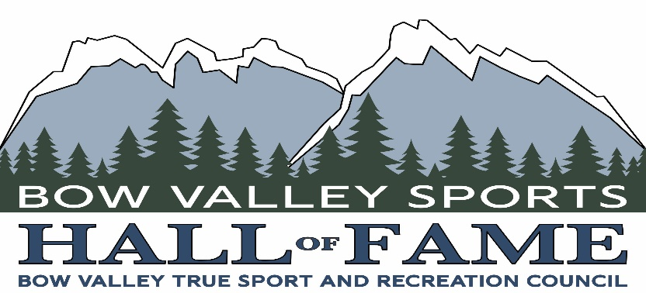

Bow Valley Sports Hall of Fame
Athlete & Coach Assistance Program - 2023

Introduction
The Bow Valley Sports Hall of Fame Athlete and Coach Assistance Program (ACAP) is a sport funding program that contributes to the pursuit of excellence in sport, and mountain pursuits. ACAP seeks to relieve some of the financial pressures associated with preparing for and participating in provincial, national and international sport and assists high-performance Bow Valley resident athletes and coaches to combine their sport and academic or working careers while training intensively while pursuing their goals. For 2023 ACAP will support up to 8 applications to a maximum of $1000 each. Deadline to apply is March 12 2023.

The Bow Valley Sports Hall of Fame
The Hall of Fame was established in 2017 by the Bow Valley True Sport and Recreation Council to honour outstanding Athletes, Builders and Pioneers in Sport, Recreation and Mountain Pursuits, as well as preserving the history of Bow Valley sport.
The mission of the Bow Valley Sports Hall of Fame is threefold:
- To honor individuals and teams from the Bow Valley who have distinguished themselves in sport, recreation or mountain pursuits.
- To assist in the development of future contributions to athletic pursuits.
- To promote our inductees to both residents and visitors to the Bow Valley.

Eligibility details
To be eligible to be considered for support through the ACAP, an athlete, or coach must:
- Be a full-time resident of the Bow Valley.
- Be a member of a club or association within the Bow Valley.
- Have a demonstrated financial need that is not supported by their sport at a local, provincial or national level.
What will ACAP support?
- Athletes
- Cost of participation at training outside of the Bow Valley.
- Travel to provincial, national, or international events that are not otherwise financially supported.
- Cost of special equipment required to continue training at a particular level.

- Coaches
- Cost to attend coaching clinics outside of the Bow Valley.
- Travel to provincial, national, or international events that are not otherwise financially supported.
- Cost of special equipment to further their coaching development.

Criteria for Application to ACAP
The following criteria will be used to evaluate all applications:
- Residency in the Bow Valley.
- Level of participation in sport in the Bow Valley.
- Level of achievement in their chosen sport.
- Statement of need to progress in sport.
- Support from a local club, or business.
- Endorse True Sport Principles: Go for It, Play Fair, Respect Others, Keep it Fun, Stay Heathy, Include Everyone and Give Back.
- Commitment to the Bow Valley. How does the applicant see sport and recreation in the Bow Valley now, and in the future and what is their anticipated role in the community going forward?

Applications for 2023
Applications need be received prior to March 12 2023, and must be completed on the form provided below. All applications will be reviewed by a committee of the Bow Valley True Sport and Recreation Council, and successful applicants will be notified by early April 2023.
Applications and/or any requests must be sent to bvtsrc@gmail.com

Bow Valley Sports Hall of Fame
Athlete & Coach Assistance Program (ACAP)
2023 Application Form

General Information

Name

Date of Birth Place of Birth

Permanent Home – Mailing Address

Permanent Home – Physical Address if different from above

Home Phone Mobile Phone

Email Address Email Address (Other)

Social Media Accounts (Facebook, Instagram, Blog or others)

Social Media Accounts (Facebook, Instagram, Blog or others)

Area of Study or Employment

Sport Information

Status (Athlete or Coach)

Name of Sport

Bow Valley Club Affiliation

Provincial and/or National Affiliation

Level of Accomplishment in your Sport

Future Plans and Goals within your Sport

Financial Expenses (One year)
- Training / Coaching / Certification
- Travel Expenses (including accommodation and living expenses)
- Competition Expenses
- Equipment
- Total cost for one year

Equipment Sponsors (Present Year)

Other Sponsors, Donors (Present Year)

Statement of Present Need

Community Statement (Bow Valley)

Declaration and Signature
I declare that I have correctly answered all questions, and that all information is true and complete; and that I will notify Bow Valley True Sport and Recreation Council if my plans change significantly and I will not be pursuing this plan as described.

Signature Date

If you are under 18 years old

Name of Parent or Guardian Signature of Parent or Guardian

Checklist:
- Application Form filled and signed
- May/should include with the application:
- Letter of support from your Club, Team or Association
- Any document to show/confirm your sport «path» (rankings, results, progression …..)

