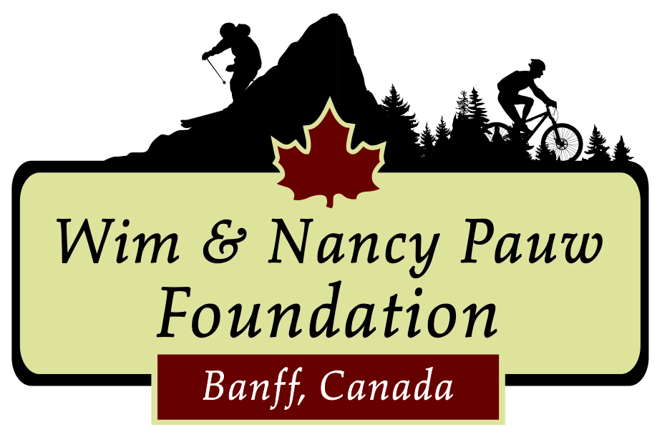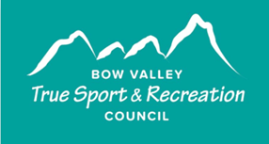

2024 True Sport Youth Fund
Call for Applications

The True Sport Youth Fund gives community sport organizations the financial support needed to keep sport inclusive and accessible in the Bow Valley. The grants are administered by the Bow Valley True Sport and Recreation Council (BVTSRC) in partnership with the Wim & Nancy Pauw Foundation.

Great impact for two of our sixteen 2023 Recipients
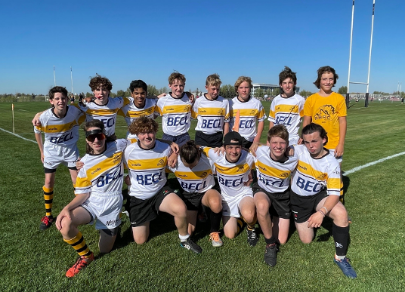
Banff Bears Rugby Club was able to make purchases for their junior team, including high-quality rugby balls for training, as well as their own team uniforms. The uniforms themselves have been a great boost in pride for their young players, and a boost to their team's spirit.

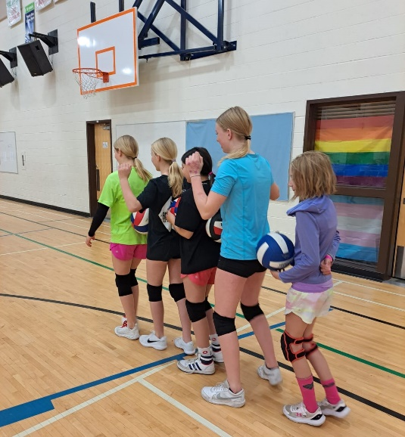
Rocky Mountain Volleyball Club will offer a new recreational, skill-building focused program for athletes who are looking for a non-competitive environment to continue to build their volleyball skills. The grant funding will be used to help hire coaches in this new recreational program.

In 2024, we are examining an approach that provides two opportunities for funding to eligible organizations:
- Base funding to eligible organizations
- Additional funding to eligible organizations pursuing a project that addresses an identified key priority.

Applications for the 2024 True Sport Youth Fund open on January 15, 2024 and close on February 12, 2024.

Eligibility Requirements

In order to apply, your sport organization must meet the following eligibility requirements:
- Ensure the majority of club participants (minimum 85%) are permanent residents in the Bow Valley;
- Offer sport, activity and recreation programs to children and youth 17 and under;
- Operate as a not-for-profit organization, administered by a Board of Directors;
- Advance programming that is consistent with the True Sport Principles
  - Go for it: Rise to the challenge – always strive for excellence. Be persistent and discover how good you can be.
  - Play fair: Understand, respect and follow the rules. Play with integrity – competition is only meaningful when it is fair.
  - Respect others: Show respect for everyone involved in creating your sporting experience, both on and off the field of play. Win with dignity and lose with grace.
  - Keep it Fun: Find the joy in sport and share it with others. Remember what you love about sport and why you play.
  - Stay Healthy: Always respect and care for your mind and body. Advocate for the health and safety of yourself and those around you.
  - Include Everyone: Recognize and celebrate strength in diversity. Invite and welcome others into sport.
  - Give Back: Say thanks and show gratitude. Encourage your sport group to make a difference in the community.

Applications must include:
- Responses to the questions provided
- Most current approved, year-ending financial statement

TRUE SPORT YOUTH FUND - 2024 APPLICATION FORM

Contact Information

Organization Name: _________________________________________________________________

Mailing Address: _________________________________________________________________

Website: _________________________________________________________________

Social Media: _________________________________________________________________

Contact Person: _________________________________________________________________

Position: _________________________________________________________________

Phone: _________________________________________________________________

Email: _________________________________________________________________

Board Members – please list

Position: Name:

______________________ _______________________________________

______________________ _______________________________________

______________________ _______________________________________

______________________ ________________________________________

______________________ ________________________________________

______________________ ________________________________________

______________________ ________________________________________

______________________ ________________________________________

Financial Statement

Please attach your most current approved, year-ending financial statement.

- BASE FUNDING QUESTIONS:

- How many children/youth participants (age 4-17) does your club have?
We are looking for the number of unique participants vs. the number of registrations.

Answer:

- How will funding from the True Sport Youth Fund be used to address a charitable community need? Specifically, what charitable purpose will be addressed through this funding grant?
Achieving a charitable purpose means that your organization is addressing affordability, providing access and inclusion for equity deserving groups, increasing or providing education, or improving and connecting community. Examples could include: coaching certification, promoting safe physical activity, reducing mental health challenges through sport, promoting good nutrition and healthy lifestyles, introducing sports to new Canadians, bring a friend events, purchasing equipment to reduce cost for participation, etc.

Answer:

- ADDITIONAL FUNDING OPPORTUNITIES:

BVTSRC has identified four priority areas that further endorse the True Sport Principles and improve the sports experience with additional attention. If your organization has a project that addresses one of the following priority areas, please share your proposal and tell us how additional funding would support your initiative.

- Growth and/or maintenance of club participant numbers
- Is the club maintaining and/or growing its base and what are any potential limiting factors around this?

Answer:

- What type of assistance would be necessary to address the limiting factors and how would your club implement a project to grow or maintain participant numbers?

Answer:

- Low Income Support
- Does the club have an established program for low-income families in the Bow Valley?

Answer:

- Does the club work with parents to help them access KidSport funding?
Answer:

- Is the club interested in establishing its own program to help support athletes in financial need? If so, what type of assistance would be necessary to develop and implement a low-income support program?

Answer:

- Team Culture
- Does your club need to implement a rigid in-house anti-bullying program or anti-bully/safe sport training program? If so, what type of assistance would be necessary to develop and implement a relevant program for your club?

Answer:

- Diversity
- Is your club interested in attracting new Canadians, Indigenous Peoples and other under-represented groups? If so, what type of support is required to make that happen?

Answer:

- Does your club already have such a program set up? If so, what type of support is required to improve your existing program?

Answer:

- OTHER CONSIDERATIONS:
BVTSRC and the Wim & Nancy Pauw Foundation are also willing to consider other challenges or needs that may be unique to your specific club or association, that support the True Sport Principles, and that achieve a charitable purpose. If that is the case, please prepare an attached proposal that outlines a specific issue and what type of financial support would be required to help address that challenge. Propose how your club would demonstrate the impact of that investment.

