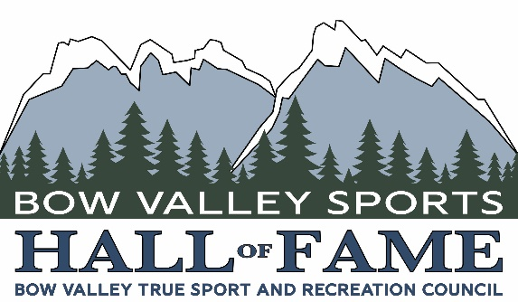

Bow Valley Sports Hall of Fame (BVSHF)

Pioneer Nomination Form – 2024 Induction

General Statement
All eligible candidates will be assessed on the following factors:
- The level and significance of their achievements/contributions to sports, recreation or mountain pursuits;
- The degree of difficulty encountered in achieving success;
- The consistency, dedication and contribution to sports, recreation or mountain pursuits over time;
- And personal qualities.
Eligible Candidates

Eligible ‘’sport and recreation’’ candidates for induction must meet the first of the guidelines below, and additionally meet two of the remaining three criteria below:

- It is physical, competitive and adheres to standard rules.
- It is a member of, or affiliated with, a provincial or national sport federation.
- It is included in multi-sport events: (i.e.) Olympics, Pan-American, Canada Games, Provincial Games, etc.
- It is, or has been, recognized as a sport by a Sports governing body of Alberta or Canada.

Eligible “mountain pursuits’’ candidates for induction must demonstrate, and be recognized by others, for a high level of excellence in mountain sports.

Eligibility Criteria

General:
- Activities of a non-competitive, self-set goal nature such as marathon swims, runs, etc. whether or not for the purpose of fund-raising, and games of skill such as billiards, darts, board games and electronic games are not eligible for nomination.
- A sports organization may not be inducted into the BVSHF in any category.
- Individuals representing an organization are permitted for induction.
- Nominees may be recognized posthumously.

Pioneers:

- Honors female or male athletes or builders that made a significant impact to the development of sport, recreation or mountain pursuits within the Bow Valley for more than 50 years prior to the year of application.

PLEASE NOTE:

Use of the nomination form is mandatory. Please ensure all sections of the nomination form are filled out as completely as possible. All areas of the form are necessary for the selection process. Nominations received in a non-standard format will be returned for re-submission. Nomination deadline is April 15th 2024.

TYPE WRITTEN SUBMISSIONS ARE REQUIRED.

PART A:

NOMINEE INFORMATION

Nominated for participation in the following sports, recreation or mountain pursuits:

Title: Miss Ms. Mr. Mrs. Dr.
Other (Please Specify)

Name:

Address:

Prov: Postal code:

Telephone: (Home): (Cell):

E-mail:

Date of birth (dd/mm/yyyy): Place of birth:

If deceased please provide date of death (dd/mm/yyyy):

Next of kin:
(Please include even if very much alive)

Address:

Prov: Postal code:

Telephone: (Home): (Cell):

I consent to my nomination being submitted for the Bow Valley Sports Hall of Fame. I have
reviewed the content of this nomination and declare that the information included is true and
correct. I will allow my name to be published in connection with the Bow Valley Sports Hall of
Fame.

Nominee’s signature:
Date:

NOMINATOR INFORMATION

Nominator name:

Address:

Prov: Postal code:

Telephone: (Home): (Cell):

Email:

(Date of Nomination) (Signature of Nominator)

PART B:

CONTRIBUTIONS AS A PIONEER

Please list details of nominee’s contribution to sport as an athlete including names of teams (if applicable), years of involvement, dates and names of championships attained, medals won, records and awards achieved (e.g., most valuable player; all-star selection) or as a builder, including names of organizations, positions held, years of service and dates and names of championship participation.

- Local (Community):

- Provincial level (i.e. Alberta, etc.):

- Western Canada (i.e. Western Regional):

- National (i.e. Canadian, Canada Games, Invitational Meets, etc.):

- International (i.e. Olympics, Worlds, Invitational Meets, etc.):

PART C:

ACCOMPLISHMENTS AS A PIONEER

- MERITORIOUS ACHIEVEMENT: Please list awards & honours bestowed upon the nominee during their athletic career. State the date of award, name of award, location of award and sponsor of award.

Please list all halls of fame that the nominee is currently installed in and the year in which the installation took place.

- ATHLETIC VERSATILITY: Please list the nominee’s involvement in other sports, recreation or mountain pursuits. Please provide specific dates and achievements recorded.

- LONGEVITY: Please outline the nominee’s accumulative involvement in sports, recreation or mountain pursuits. For each please list (1) year began, (2) year ended, (3) years not involved, if applicable, and (4) total # of years involved.

PART D:

CONTRIBUTIONS AS A PIONEER

Please list details of the nominee’s contribution to sports, recreation or mountain pursuits in the capacity of a pioneer.

PART E:

OTHER CONTRIBUTIONS

If the nominee has contributed to sports, recreation or mountain pursuits in ways not covered by sections b, c, and d, please provide details here.

NOMINATION DEADLINE

Nominations must be received at the Bow Valley Sports Hall of Fame by 11:59 p.m. on April 15th 2024.

A digital nomination form copy must be sent by email plus a hard copy by mail with all required attachments.

Email address:

bvtsrc@gmail.com

Mailing address:

Induction Selection Committee
Bow Valley Sports Hall of Fame
P.O. Box 8462
Canmore Alberta T1W 2V2

FINAL CHECKLIST FOR NOMINATIONS:

Please ensure that you have included the following items in your package:

- Nomination Form completed in its entirety and signed by the nominator.
- Nominee’s signature acknowledging the accuracy of the information and authorizing
submission of the Nomination Form.
- A 5’’ x 7’’ photograph of the nominee. Head & Shoulder photograph only. No scanned photographs.
- Letters of support.

PLEASE NOTE: a nomination is considered incomplete until all items have been submitted.

