**

**2025 True Sport Youth Fund**

**Call for Applications**

The True Sport Youth Fund gives community sport organizations the financial support needed to keep sport inclusive and accessible in the Bow Valley. The grants are administered by the Bow Valley True Sport and Recreation Council (BVTSRC) in partnership with the Wim & Nancy Pauw Foundation.

**Great impact for two of our nineteen 2024 Recipients**

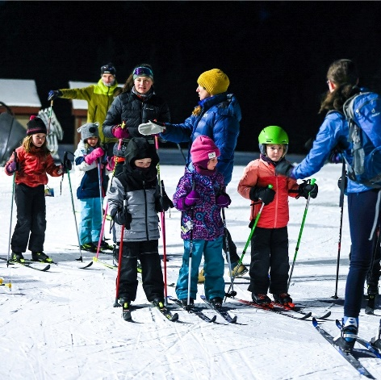

**Canmore Nordic Ski Club**

‘’ The True Sport Youth Fund support is very impactful for the Canmore Nordic Ski Club to train and certify our Jackrabbit Leaders. The fund covers the cost of education and training which helps our young coaches (primarily 16-18 years old) learn essential skills through the National Coaching Certification Program courses and then teach the next generation of skiers in the Bow Valley’’.

Matt DeCarufel, Program Director

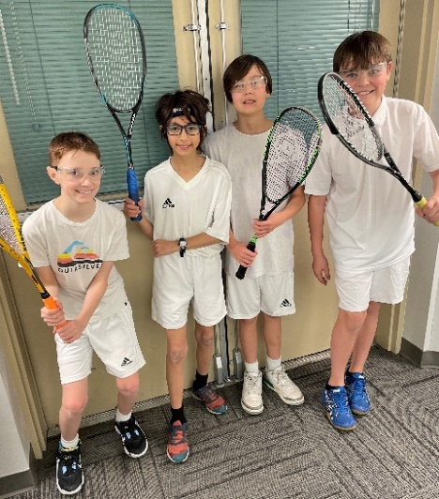**Bow Valley Squash Foundation**

‘’The Bow Valley Squash Foundation benefits from the True Sport Youth Fund grant which helps cover coaching costs for its 3 seasons (fall, winter & spring) junior outreach program and supports local coach development.”

Kevin Arnsdorf, President

In 2025, we are examining an approach that provides two opportunities for funding to eligible organizations:

1. Base funding to eligible organizations
2. Additional funding to eligible organizations pursuing a project that addresses a charitable purpose and an identified key priority for your club or association.

Applications for the 2025 True Sport Youth Fund open on January 17, 2025 and close on February 18, 2025.

**Eligibility Requirements**

In order to apply, your sport organization must meet the following eligibility requirements:

* Ensure the majority of club participants (minimum 85%) are permanent residents in the Bow Valley.
* Offer sport, activity and recreation programs to children and youth under 18 years of age.
* Operate as a not-for-profit organization, administered by a Board of Directors.
* Advance programming that is consistent with the True Sport Principles
  + **Go for it**: Rise to the challenge – always strive for excellence. Be persistent and discover how good you can be.
  + **Play fair**: Understand, respect and follow the rules. Play with integrity – competition is only meaningful when it is fair.
  + **Respect others**: Show respect for everyone involved in creating your sporting experience, both on and off the field of play. Win with dignity and lose with grace.
  + **Keep it Fun**: Find the joy in sport and share it with others. Remember what you love about sport and why you play.
  + **Stay Healthy**: Always respect and care for your mind and body. Advocate for the health and safety of yourself and those around you.
  + **Include Everyone**: Recognize and celebrate strength in diversity. Invite and welcome others into sport.
  + **Give Back**: Say thanks and show gratitude. Encourage your sport group to make a difference in the community.

**Applications must include:**

* Responses to the questions provided
* Most current approved, year-ending financial statement

**TRUE SPORT YOUTH FUND - 2025 APPLICATION FORM**

**Contact Information**

Organization Name: _________________________________________________________________

Mailing Address: _________________________________________________________________

Website: _________________________________________________________________

Contact Person: _________________________________________________________________

Position: _________________________________________________________________

Phone: _________________________________________________________________

Email: _________________________________________________________________

**Board Members – please list**

Position: Name:

______________________ _______________________________________

______________________ _______________________________________

______________________ _______________________________________

______________________ ________________________________________

______________________ ________________________________________

______________________ ________________________________________

______________________ ________________________________________

______________________ ________________________________________

**Financial Statement**

Please attach your most current approved, year-ending financial statement.

**BASE FUNDING QUESTIONS:**

1. **How many children/youth participants (age 4 - under 18) does your club have? We are looking for the number of unique participants vs. the number of registrations.**

**Answer:**

1. **How will funding from the True Sport Youth Fund be used to address a charitable community need? Specifically, what charitable purpose* (see note below) will be addressed through this funding grant and how will you specifically use the funds?**

**Answer:**

**ADDITIONAL FUNDING REQUEST:**

**Does your organization have a priority project or program that is currently unfunded or under-funded? Does it address a charitable purpose in our Bow Valley community? If that is the case, please prepare an attached proposal that outlines a specific issue and what type of financial support would be required to help address that priority project or program. Propose how your club would demonstrate the impact of that investment.**

*Charitable Purpose: There are several charitable purposes to consider: relief of poverty, advancement of education and other purposes beneficial to the community.