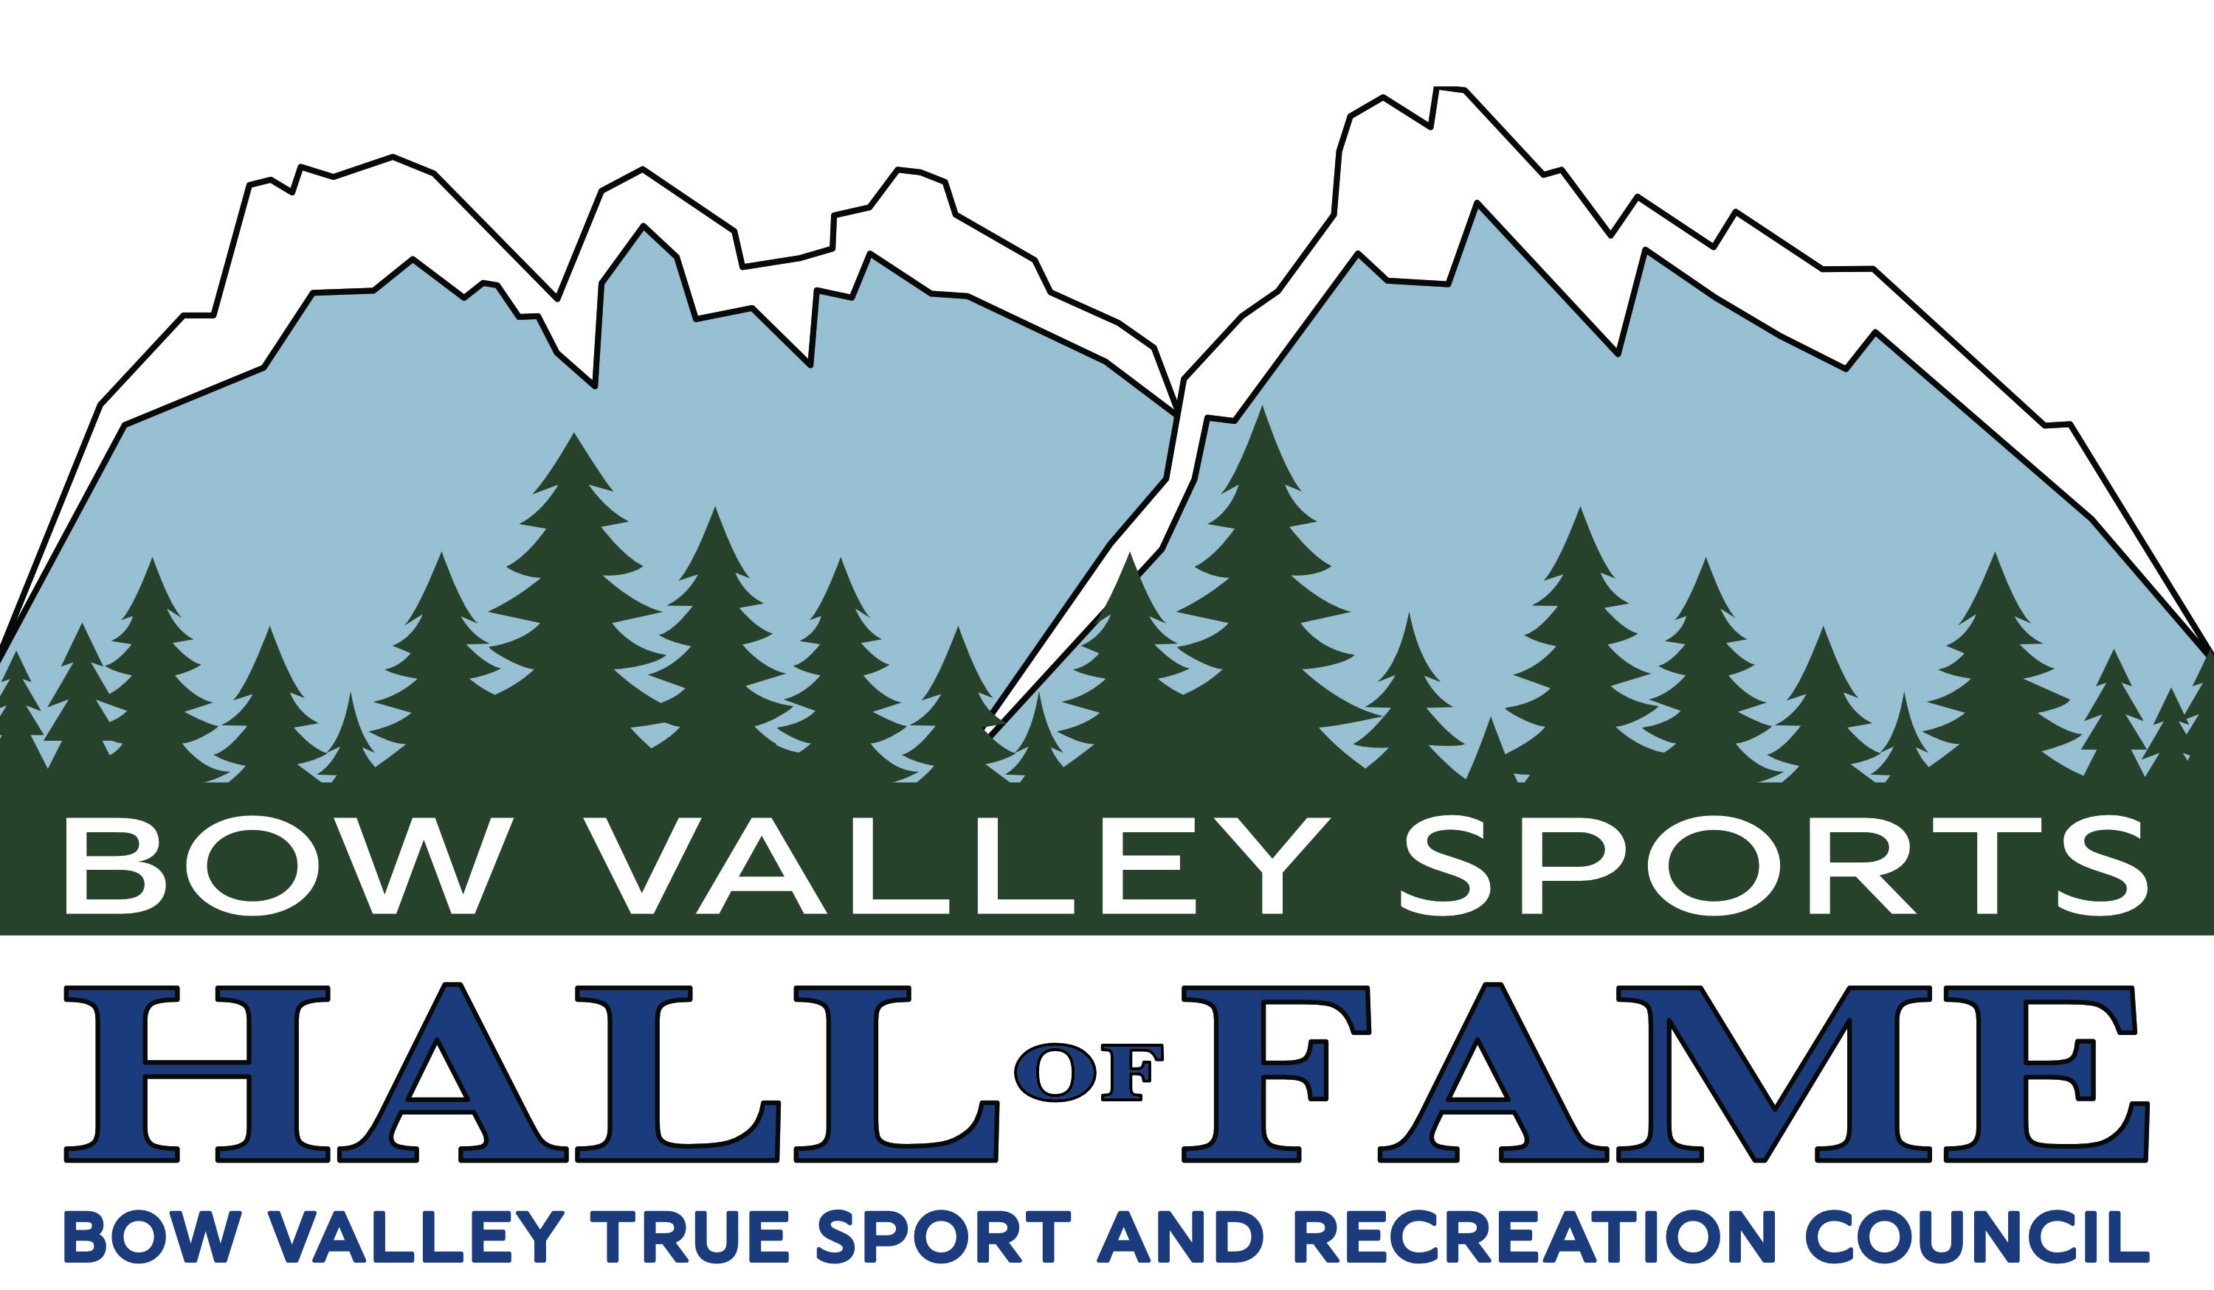

April 15, 2026

PRESS RELEASE

BOW VALLEY SPORTS HALL OF FAME
CALL FOR 2026 NOMINATIONS

The Bow Valley Sports Hall of Fame, is pleased to issue a request for nominations to the Class of 2026 of the Bow Valley Sports Hall of Fame.
The Hall of Fame was established to honour outstanding Bow Valley athletes and sport builders as well as preserving the history of Bow Valley sport.
The mission of the Bow Valley Sports Hall of Fame is threefold:
- To honour individuals and teams from the Bow Valley who have distinguished themselves in sport, recreation or mountain pursuits.
- To assist in the development of future contributions to athletic pursuits.
- To promote our inductees to both residents and visitors to the Bow Valley.

There will be three categories within the Hall that will recognize the athletic achievements of residents from the Bow Valley:
- Athlete: direct participant in sports, recreation or mountain pursuits.
- Builder: conducting athletes in a leadership capacity ... coach, trainer, manager, official, administrator, etc.
- Pioneer: athletes or builders that made a significant impact on the development of sport, recreation or mountain pursuits within the Bow Valley for more than 50 years before the current date.

Our Class of 2024 was:
- Brian McKeever – Athlete / Nordic Skiing
- Norbert Meier – Builder / Nordic Skiing
- Ken Davies – Builder / Biathlon
- Pete Bosinger – Builder / Alpine Skiing
- Jim Davies – Pioneer / Mountain Pursuits
- Ryan, Kevin and Jared Smyth – Athletes / Hockey

The Bow Valley Sports Hall of Fame is operated by the Bow Valley True Sport and Recreation Council.

Nomination forms are available at bowvalleysport.ca/2026-induction-call
The application deadline is May 31st, 2026.
Question regarding the Bow Valley Sports Hall of Fame may be directed to Mario Leonard at bvtsrc@gmail.com

