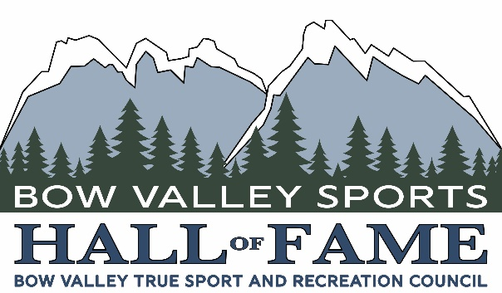

April 15, 2026

BOW VALLEY SPORTS HALL OF FAME
NOMINATION CRITERIA

On behalf of the Board of Directors of the Bow Valley Sports Hall of Fame you are invited to participate in a nomination process that will promote and celebrate our community through honoring the many women and men from the Bow Valley who make us proud in their athletic pursuits.

The goal of the Bow Valley Sports Hall of Fame is to honor individuals from the Bow Valley who have distinguished themselves in sports, recreation or mountain pursuits, to assist in the development of future contributions to athletic activities, and to promote our inductees to both residents and visitors to the Bow Valley.

Nominations will be accepted in each of three categories:

Athlete: Direct participant in sports, recreation or mountain pursuits.

- An ATHLETE must have participated in sports, recreation, or mountain pursuits.
- An ATHLETE must have been a resident of the Bow Valley for a minimum of five (5) years during the relevant part of his or her career and/or skill development
- An ATHLETE must have developed his or her skill level to a national or international standard while a permanent resident of the Bow Valley, but may have gone elsewhere during their career and achieved greatness
- An ATHLETE does not qualify if they had temporary residency in the Bow Valley, simply for training, while maintaining permanent residency elsewhere.
- An ATHLETE will be evaluated with respect to his/her contribution to sport, recreation or mountain pursuits at the international, national, and provincial levels.
- Normally, an ATHLETE must be retired from national championships or higher-level competitions. An exception may be given for ATHLETES who win Olympic medals or similar accomplishments.
- In the event of a potential candidate’s death, there is a 2-year waiting period, after their death.
- Subject to qualified applicants and at the discretion of the Board of Directors, we wish to have an average of two (2) inductees per year, in this category.

Builder: Conducting athletes in a leadership capacity: coach, trainer, manager, official, administrator etc.

- A BUILDER must have been a resident of the Bow Valley for a minimum of ten (10) years during the relevant part of his or her career.
- A BUILDER directs athletes in a leadership capacity.
- A BUILDER is a coach, trainer, manager, official, administrator, volunteer, facility/program developer, or media member, but is not a professional promoter, sponsor or fundraiser.
- A BUILDER may be either active or inactive to be considered.
- A BUILDER shall be evaluated for his or her outstanding effort and the impact he or she has made in one or more sports, normally over a period of ten (10) years, but not necessarily consecutive.
- Subject to qualified applicants and at the discretion of the Board of Trustees, there will normally be no more than two (2) inductees per year in this category.

Pioneer: Athletes or builders that made a significant impact on the development of sports, recreation or mountain pursuits within the Bow Valley 50 years prior to the year of application.

- The PIONEER Award honors female or male athletes or builders that made a significant impact to the development of sports, recreation or mountain pursuits within the Bow Valley prior to and including 1976.
- Subject to qualified applicants and at the discretion of the Board of Trustees, there will normally be no more than one (1) inductee per year in this category.

Nominations for the Bow Valley Sports Hall of Fame are open as of April 15 2026 and will be accepted until May 31 2026.

Anyone may participate in the nomination process. Simply send a completed nomination package.

Nomination forms are available at bowvalleysport.ca/2026-induction-call

GUIDELINES

- An individual or organization may annually submit two nominations in each of the athlete, builder and pioneer categories.
- Nominations will be considered posthumously, two years after the nominee’s death.
- Nominees will be considered for induction in the year nominated, and, if requested by the nominator, for up to two (2) successive years thereafter.
- In the event that a nominee is not selected for induction within the three-year period, the nomination will be declared inactive and may only be resubmitted after a period of five (5) years has elapsed.
- A maximum of five (5) pages of supporting documentation may accompany each nomination.

Submit your nominations and promote and celebrate our community through honoring the best in sport, recreation and mountain pursuits from the Bow Valley by bringing recognition to the role sport, athletes, pioneers and builders play in the pride we feel for our community.

For any questions please send an email to Mario Leonard: bvtsrc@gmail.com

